**3rd assignment of c programing .**

**Student Name : محمد ابراهيم محمد السعيد ابراهيم**

**ID : 18011342**

**Section or lab : 8**

**Electrical communication engineering.**

***Code 1***

#include <stdio.h>

#include <stdlib.h>

int main()

{

int num1 , x , y , z , i ;

printf("please enter a +ve number\n");

scanf("%d",&num1);

while(num1<0){

printf("please enter a +ve number not a -ve one\n");

scanf("%d",&num1);

}

x=num1;

y=1;

for (i=1;i<=x;i+=2){

z=i/y;

if (z==y){

printf("%d\n",i);

y++;

}

}

return 0;

}

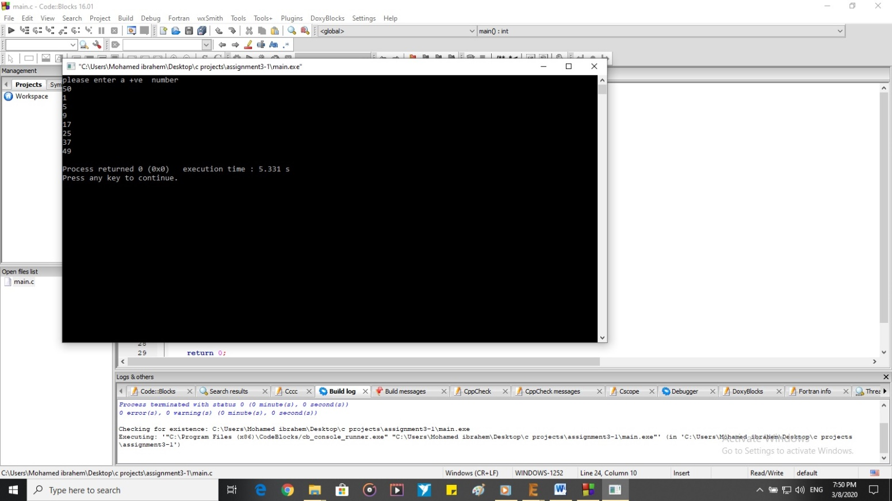

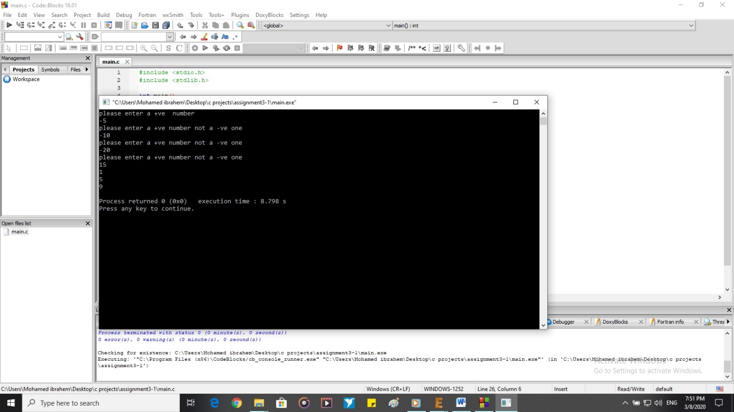

***Code 2:-***

#include <stdio.h>

#include <stdlib.h>

int main()

{

int x , y , z , w , a , b , c , d ,i,j;

printf("we have an equation here we just need you to enter its coefficients\n");

printf("the equation is a*(x*x)-b*(y*y*y)-c*(z)=d*(w*w) \n");

printf("so please enter a \n");

scanf("%d",&a);

printf("so please enter b \n");

scanf("%d",&b);

printf("so please enter c \n");

scanf("%d",&c);

printf("so please enter d \n");

scanf("%d",&d);

j=1;

for ( x=1; x<=20; ++x)

{

for ( y=1; y<=20; ++y)

{

for ( z=1; z<=20; ++z)

{

for ( w=1; w<=20; ++w)

{

if (a*(x*x)-b*(y*y*y)-c*(z)==d*(w*w))

{

printf("Solution%d: x=%d y=%d z=%d w=%d\n",j,x,y,z,w);

j++;

}

}

}

}

}

if(j==1){

printf("there is no solution for this equation with those coefficients\n");

}

return 0;

}

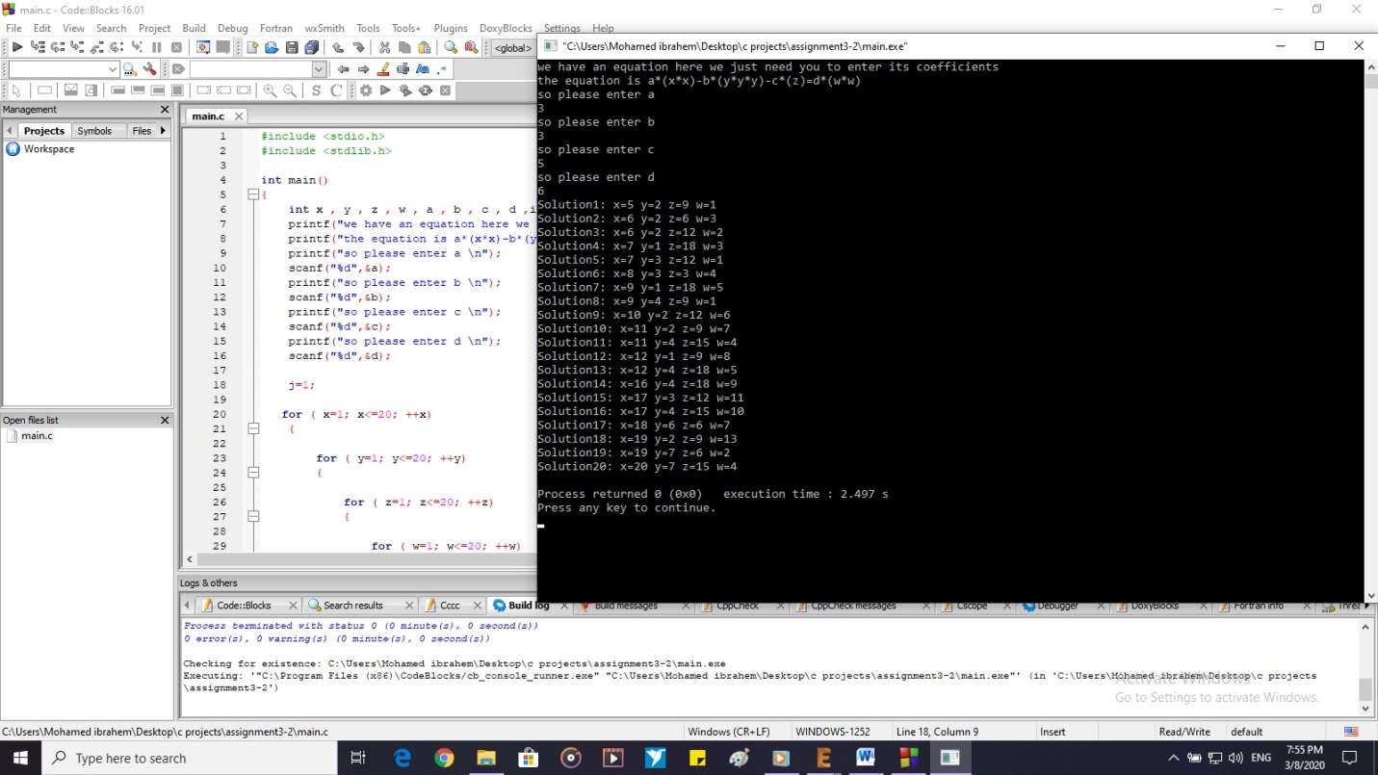

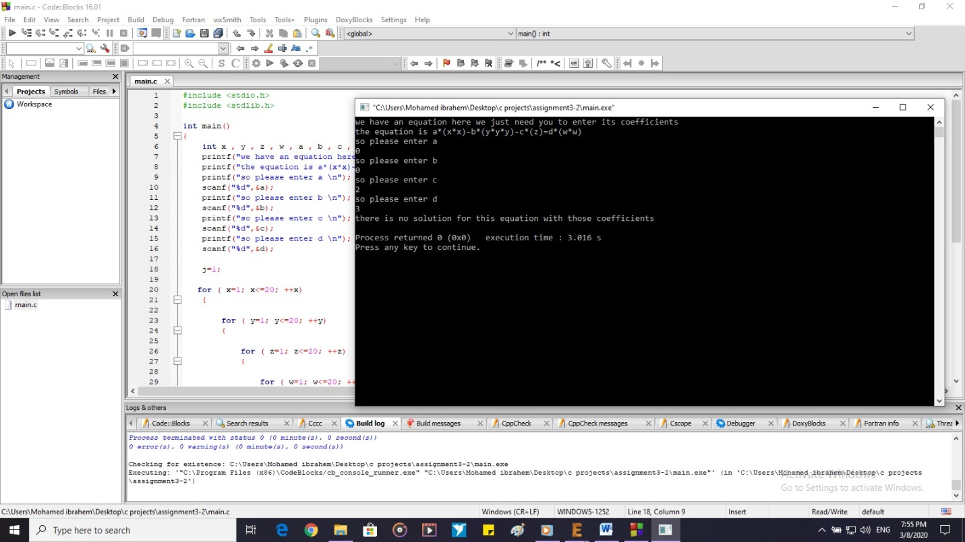

***Code 3:-***

#include <stdio.h>

#include <stdlib.h>

int main()

{

int i , n , m,j,k,l,h , space;

int f ;

char z;

z='*';

printf("please enter the heart number\n");

scanf("%d",&n);

k=n-1;

m=2*n-1;

for(space=k;space>0;space--){

printf(" ");

}

printf("%c",z);

printf("\n");

k--;

for (j=3;j<=m;j+=2){

for(space=k;space>0;space--){

printf(" ");

}

for (i=0;i<j;i++){

printf("%c",z);

}

printf("\n");

k--;

}

k=n-1;

for (l=0;l<3;l++){

for(space=0;space<l;space++){

printf(" ");

}

for (i=0;i<k;i++){

printf("%c",z);

}

for(space=0;space<(l+1);space++){

printf(" ");

}

if(l==1){

printf(" ");

}

if(l==2){

printf(" ");

}

for (i=0;i<k;i++){

printf("%c",z);

}

printf("\n");

k-=2;

}

return 0;

}

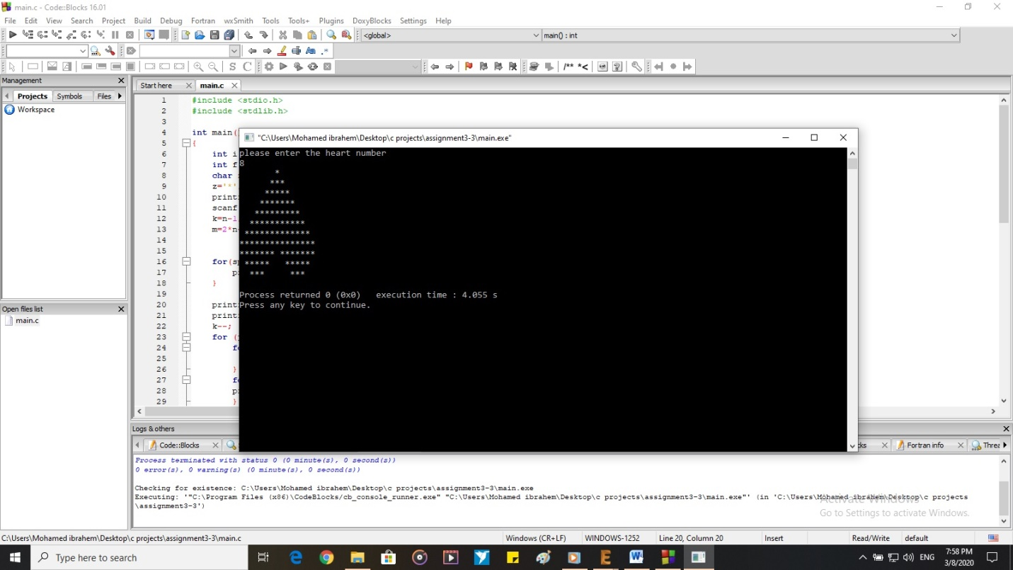

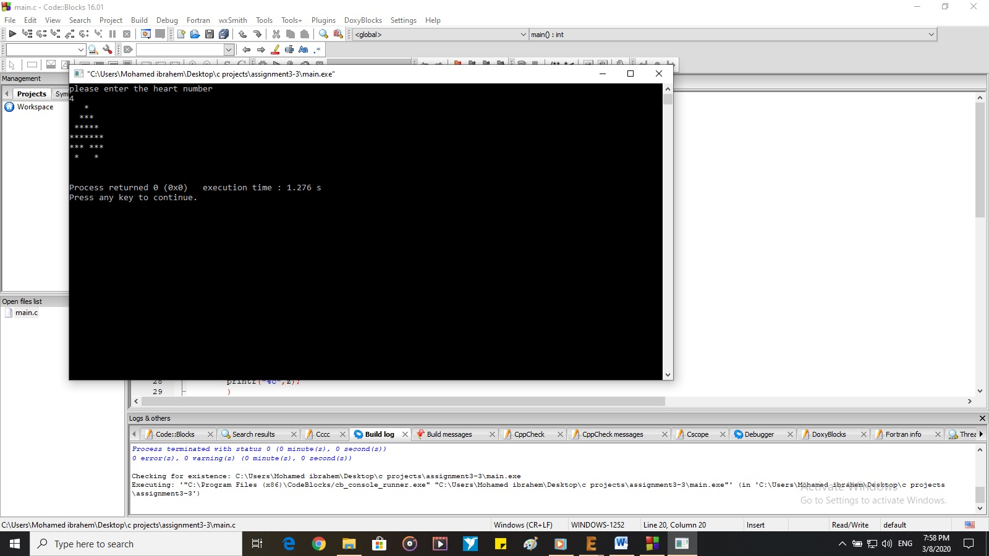

***Code 4 : the bonus one :D***

#include <stdio.h>

#include <stdlib.h>

int main()

{

int x , i , h,k,l ,a,space;

printf("please enter the number of the pattern\n");

scanf("%d",&x);

k=x/2;

for(space=k;space>0;space--){

printf(" ");

}

for (h=0;h<(x/2);h++){

printf("**");

printf(" ");

}

k--;

for(i=0;i<(x/2-1);i++){

printf("\n");

for(space=k;space>0;space--){

printf(" ");

}

k--;

printf("**");

}

printf("\n");

for(i=0;i<(x/2+1);i++){

printf("**\n");

}

for(l=1;l<=(x/2-1);l++){

for(space=1;space<=l;space++){

printf(" ");

}

printf("**");

if(l==(x/2-1)){

for(a=0;a<(x/2-1);a++){

printf(" ");

printf("**");

}

}

printf("\n");

}

return 0;

}

